Clover County Fair
Superintendent Check List- Livestock Projects

- Organize your helpers, and have each person accept responsibilities, i.e. ring help, ribbon help, gate person, etc.
- Assist Fair board at livestock check-in with weigh-in, checking tags, papers, finding stalls/pens, etc. All livestock are to be checked-in between 8:00-9:00 am on Thursday, July 16, 2018.
- On day of show, please pick up your respective supplies & ribbons at the fair office 30 minutes prior to show time.
- Introduce yourself to judge. Direct him or her to the fair office for payment, bathrooms, etc.
- Chris Clover, Livestock Superintendent, will announce all of the livestock shows. Announce when show will start in 10 minutes. Begin shows on time!
- Refer to the fair book for your project’s guidelines and rules should questions arise.
- Assist the judge, but do not converse about the animals. It is your responsibility to ensure that the judges are following our rules as stated in our fair book.
- During the show, offer water periodically to the judge.
- Mark the placings correctly on the show bill. Below are the correct ribbon abbreviations:
GC- Grand Champion RGC- Reserve Grand Champion
B- Blue R- Red W- White

- When judging is complete, turn in official results show bill, supplies and all extra ribbons, medals, etc. into the Fair Office.
- Check specie area periodically each day during the fair to assist fair board/agents in ensuring clean pens, clean water, fed animals, etc.
- 4-H age divisions are as follows, as of January 1, 2018:
Junior (7-9)
Intermediate (10-13)
Senior (14 and older)

- MOST IMPORTANTLY, SMILE! Fair should be a fun, educational experience and an opportunity for learning. We should enjoy ourselves ☺!

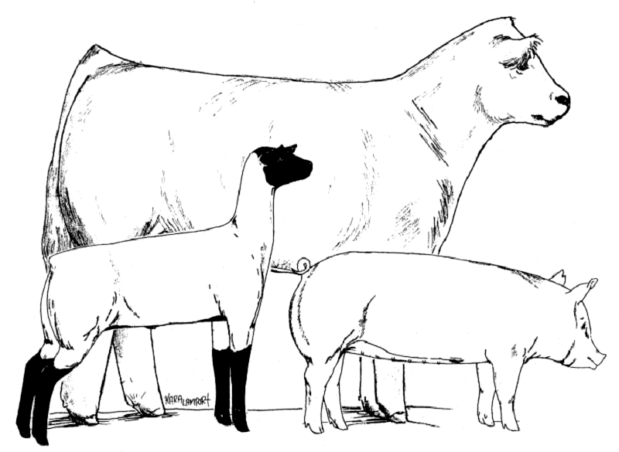
Thank you!

